Workpaper REST Endpoints:

|  |  |
| --- | --- |
| **Endpoint** | **Description** |
| /template | Template API |
| /datarequest | Data Request API |

A simple search portal for both the template and user data is available here. => <http://glm-ml-dev.amers1.cis.trcloud:8010/>

**/template**

| # | Type | Action |
| --- | --- | --- |
| 1 | POST | Uploads a new template file that physically resides on the local client directory. |
| 2 | GET File | Returns specific template spreadsheet file. |
| 3 | DELETE | Soft Delete – Archives the Template file and its metadata. |

**/datarequest**

| # | Type | Action |
| --- | --- | --- |
| 1 | POST | Creates a new User Data file. |
| 3 | GET Merged File | Return merged spreadsheet file. Returns binary xlsx file. |
| 4 | GET Specific User Doc | Return User Data File. Returns specific user data file. |

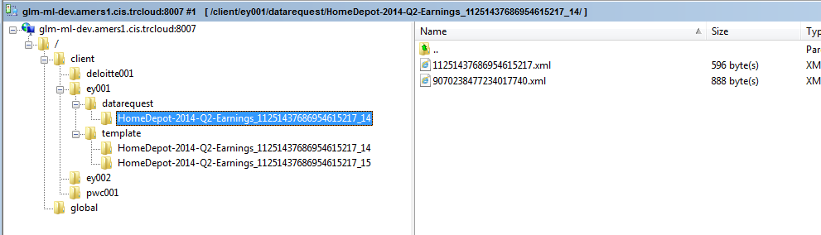

Endpoint Details:

1. Template API – Used for Workpaper Template CRUD Operations

| # | Type | Parameters | Action |
| --- | --- | --- | --- |
| 1 | POST | **Parameters:**  rs:filename – required  **Examples:**  /template  /template?fs:filename=C590300 | Uploads a new template file that physically resides on the local client directory.  The filename must be provided.  The payload is the binary Excel file.  API returns the template ID and URI.  The binary file with its respective metadata file is stored in the dedicated directory (see image).  **Curl Commands:**  In this case, the template file is indicated by “./C5903000.xlsx”.   1. POST Template File with desired filename.   curl -X POST --data-binary @./C5903000.xlsx \      --header "Content-Type:application/vnd.openxmlformats-officedocument.spreadsheetml.sheet" \  <http://glm-ml-dev.amers1.cis.trcloud:8010/v1/resources/template?rs:filename=C5903000> |
| 2 | PUT | **Parameters:**  rs:id – template ID  **Example:**  /template?rs:id=7940446531123017941 | Updates (overwrites) an existing Template file.  The payload is the binary Excel file.  Be sure to appropriate template id (rs:id). If necessary, use the following GET APIs to find the appropriate id.  Returns the template ID and URI.  **Curl Commands:**   1. PUT Template File – update existing template file if one exists.   curl -X PUT --data-binary @./C5903000.xlsx \      --header "Content-Type:application/vnd.openxmlformats-officedocument.spreadsheetml.sheet" \  <http://glm-ml-dev.amers1.cis.trcloud:8010/v1/resources/template?rs:id=7940446531123017941> |
| 3 | GET File | **Parameters:**  rs:id – Template ID  **Example:**  /template?rs:id=8216640002390149622 | Returns specific template spreadsheet file.  **Curl Commands:**   1. GET Binary by Template ID 8216640002390149622   curl --anyauth --user grusso:password -o templateC5903000.xlsx -X GET \    -H "Accept: application/vnd.openxmlformats-officedocument.spreadsheetml.sheet" \    -r "0-511999" \  <http://glm-ml-dev.amers1.cis.trcloud:8010/v1/resources/template?rs:id=8216640002390149622> |
| 4 | GET - List | **Parameters:**  rs:pg – page (not yet implemented)  rs:ps – page size  **Example:**  /template?rs:pg=2&rs:ps=10 | Returns the list of IDs and URIs of all Template Excel files. Pagination parameters are not yet implemented.  **Curl Commands:**   1. GET List of Templates using a search term:   BEPS AND juris:Brazil   curl --anyauth --user grusso:password -X GET \      -H "Accept: application/xml" \  <http://glm-ml-dev.amers1.cis.trcloud:8010/v1/resources/template> |
| 5 | GET - Search | **Parameters:**  rs:q – Search Term  rs:pg – page (not yet implemented)  rs:ps – page size  **Example:**  /template?rs:q=BEPS AND juris:Brazil | Searches templates using terms especially Ontology terms.  Returns list of templates with search relevance scores.  **Curl Commands:**   1. GET List of Templates using a search term:   BEPS AND juris:Brazil   curl --anyauth --user grusso:password -X GET \      -H "Accept: application/xml" \      "[http://glm-ml-dev.amers1.cis.trcloud:8010/v1/resources/template?rs:q=BEPS AND juris:Brazil](http://glm-ml-dev.amers1.cis.trcloud:8010/v1/resources/template?rs:q=BEPS%20AND%20juris:Brazil)" |
| 6 | DELETE | **Parameters:**  rs:id – template Id  **Examples:**  /template?rs:id=7940446531123017941 | Deletes the Template file and its metadata.  **Curl Commands:**   1. DELETE Template File   curl --anyauth --user grusso:password -X DELETE \      -H "Accept: application/xml" \  <http://glm-ml-dev.amers1.cis.trcloud:8010/v1/resources/template?rs:id=7940446531123017941> |

1. Data Request API – Used for Workpaper Data Request CRUD Operations